COMP471 JAVA PROGRAMMING
HOMEWORK
Spring 2023-24
DUE(25/5/2024 23:55PM)

Please read the last page ( submission guidelines) before you start to the project.

For below given UML diagram please construct the related classes and interfaces

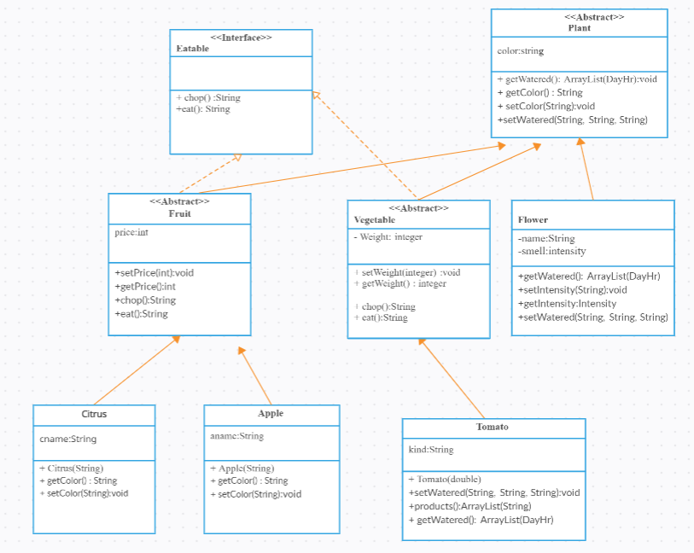

Note: Note that in the above diagram only the specific functions and variables for each class is provided. Therefore, if you need to have some inherited functions because of the relationships among the classes please add them to your code and write what you added into the assumptions.doc document. If return type of the function is not mentioned you can consider it as a void.
- Create an abstract Plant class, which is the abstract superclass of Fruit, Vegetable and Flower classes.
- implement setWatered and getWatered fuctiontions for the plant. Note that DayHr is a class holds the watering time and getWatered function will return all the set times ( in terms of day and hour and duration) the plant should be watered in a week. The default plan is set for 10 am on Mondays and the duration is 1 hr.
- Define an abstract fuctions setColor and getColor which they are used to set and get color of plant
- Create an interface Eatable with chop and eat functions
- Create Flower subclass of a Plant class.
  - The Flower class has a name attribute of a class and a smell intensity which intensity should be enumerated from 1 to 5 as very strong, strong, middle, weak, very weak
  - Create set and get methods for intensity
- Create an abstract Fruit class.
  - Write set and get price functions for a fruit.
  - Implement chop function and write a string “ don’t chop the fruit byte it”
  - Implement eat function of a class and write string “ you should eat fruits raw”
- Create an abstract Vegetable class.
  - Write set and get weight functions for a vegetable.
  - Implement chop function and write a stringn “ chop the vegetable dont byte it”
  - Implement eat function of a class and write string “ you should eat vegetables cooked”
- Create a citrus class which is a subclass of a Fruit
  - By citrus function set the name of the citrus
  - Set and get the color of the citrus
- Create an apple class which is a subclass of a Fruit
  - By apple function set the name of the apple
  - Set and get the color of the apple
- Create a subclass Tomato which is a subclass of Vegetable
  - In tomato function determine the type of tomato.
  - Override setwatered and getwatered functions and schedule a plan for Monday, Wednesday and Friday from 9am to 9.30 am
  - Make a list of products which we can make from tomato ( ex: tomato soup, tomato paste, ketcup)
9. Create test program to create and call the functions of the given classes for the given objects.
- Add one item for citrus, apple, tomato and flower classes through test program.
10.After the previous step, use Graphical user interface to add and search information from the data structures. initial GUI is provided in figure 1
NOTE THAT YOU SHOULD NOT USE ABSOLUTE LAYOUT FOR THE GUI. PLEASE USE FLOWLAYOUT, GRIDLAYOUT AND BORDERLAYOUT COMBINATIONS ONLY.
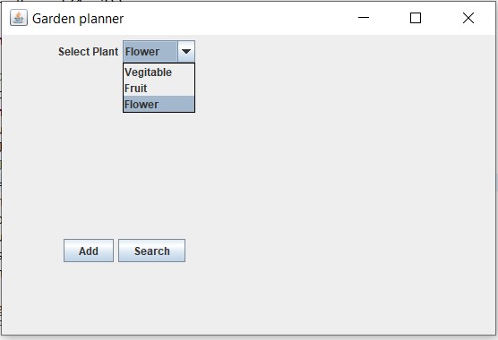
Figure 1: initial GUI
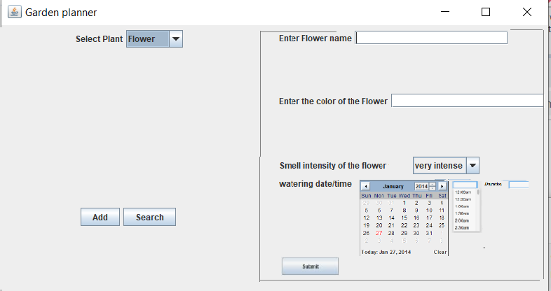
Figure 2: When Flower is selected and add button is pressed
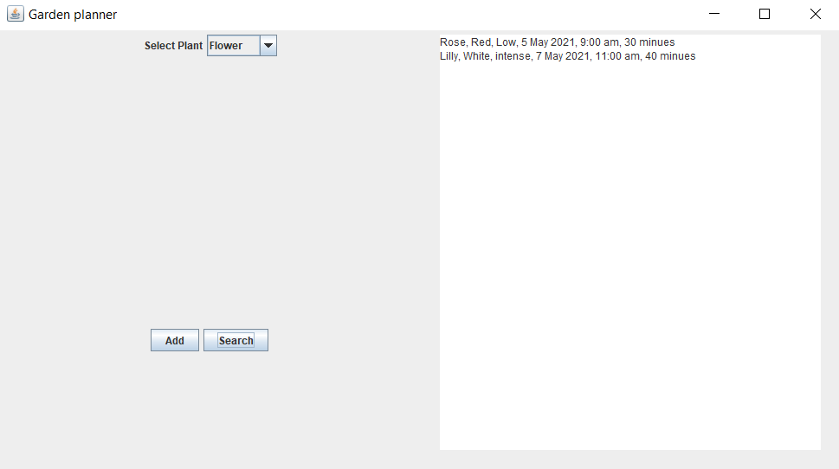
Figure 3: When Flower is selected and search button is pressed
The above graphical user interface (figure 2) is the sample for adding a new flower item. The left hand side of the panel is fixed which user can select from the drop down menu “ vegetable, fruit, flower” categories. Then if user press add button. A panel on the right related to adding particular items data should appear (notice that the right hand side will change based on the selected plane). For flower, the user will enter name, color, smell intencity and watering plan information (user should select date and time and should enter number of minutes for watering). PLEASE DO NOT USE ADDITIONAL LIBRARY FOR THE DATE AND TIME. CREATE NECESSARY CLASSES
Once the user press add button, the object with the provided information should be created. Therefore when you click on search button for a related plant without closing the frame, you should see the added item in the results as in figure 3
Again when you select fruit and press add button you should see figure 4. Once the information is filled and submit button is presses the object for the related fruit should be created. We are assuming that user enters only orange and apple kinds.
Question:Please state how you differentiate apple and orange objects since you just select fruit. Do you need to do anything about that? Answer this on assumptions.doc document

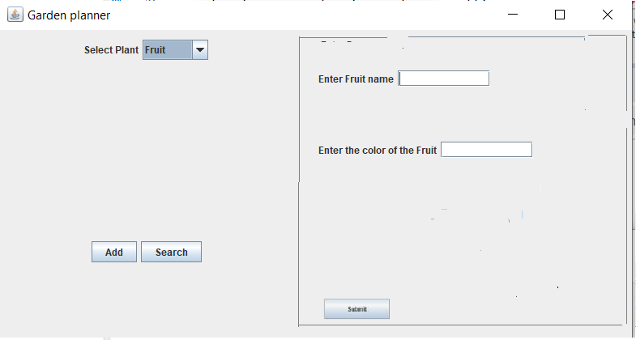
Figure 4: when “add” button is presses for fruit

Submission Guidelines

- This is an individual project. Your project will be checked for plagiarism which means similarity with other resources will get 0.
- Please submit a functional java code. Even if it does not do all the tasks, your code should compile without an error. Program that do not compile and run will not get any points
- Write all your java code in one java file named yourname_initial of last name.java (ex:vesile_e.java) Make sure that it works before submission. Note that as far as you have one main function, you can have several classes
- You will also have assumption.doc file to write your assumptions and aswers to the several questions above. Once you write the text information please paste the content of yourname.java file content into this document. Therefore assumption.doc document will have the descriptions followed by the content of yourname.java file.
- You need to submit two files zipped as

student_no_name_comp471sp23-24.zip

to the reserved place in Moodle by 25/5/24 at 23.55. Late submissions or submissions from other mediums won’t be accepted.

Grading criteria

Note that the look should be the same as the given figures
- Figure 1 10 points
- Getting figure 2 by add button of figure 1 20 points
- Getting figure 4 by add button of figure 1 10 points
- Figure 3 ( for selected fruit, flower) when to click on search button from figure 1 to have the available products including the newly added ones (20 points)
- The question in the problem (10 points)
- Class creations and compatibility with the UML 30 points

Good Luck,
Vesile

